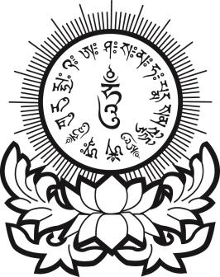
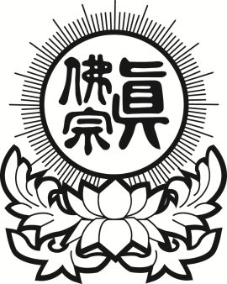
真佛宗紐約金剛雷藏寺
True Buddha Diamond Temple of NY
33-32 148th Street, Flushing, NY 11354
Tel: (718) 888-7919 Fax: (718) 888-1966

超度法會報名表格
（Bardo Deliverance Ceremony Registration Form）
祖先(亡者)姓名  （Name of deceased） | 安靈地址  （Address of Deceased or Spirit） | 祈願  （Dedication）
有意無意所傷害之眾生靈
(Intentionally killed or unintentionally killed sentient beings)
近代祖先(Ancestor)
近代祖先(Ancestor)
之水子靈(Attached Baby Spirits)
之土地公、地基主(Local Earth Deity)
之冤親債主纏身靈
(Karmic Enemies & Attached Spirits)
陽居善信，一心至誠，虔誠供養，仰叩蓮生活佛、阿彌陀佛、觀音勢至、地藏慈尊、諸佛、菩薩，
靈光加庇，超度報名眾靈眾等，罪孽消除，悉獲超昇，往生極樂；俾陽居眾，安居樂業，生意興旺，事業昌隆，身體強健，如意吉祥。伏乞慈悲，虔誠是禱。

報名隨意供養 (Donation) …………………………………... $_______________
供品花果贊助 (Offering of fruits and flower) ……………… $_______________
總數Total： $_______________
支票抬頭(Check or Money Order Payable to) : True Buddha Diamond Temple of NY
陽世報恩人姓名(Name Of Living Beneficiary)：
地址(Address)：

